Introduction to Assignment Rules: Group Assignment

Exercise 1: Investigation

In this exercise, you will use breakpoints in ClaimCenter Studio to observe the execution of assignment rules.

Make sure that you have the ClaimCenter server running in Studio in a debug process (if you haven’t already done this already). Refer to the instructions on the second page of the **“ClaimCenter Data Model”** lab to start the server in this way.

1. In ClaimCenter Studio, set break points by clicking in the blank gray column in between the line number and the code at the first rule in both the Global Claim Assignment rule set and Default Group Claim Assignment rule set:

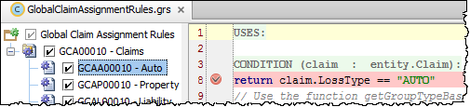

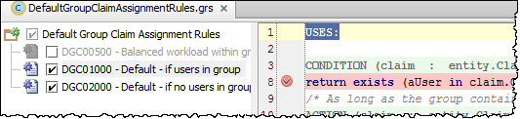

1. Log on to ClaimCenter as Andy Applegate and navigate to one of Andy’s claims. Reassign the claim (Actions > Assign Claim) using "Use automated assignment". Step through the code.

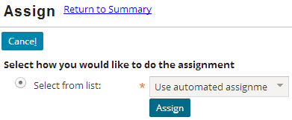

* 1. Did the Global Claim rules execute?
  2. Did the Default Group rules execute?

1. Repeat the process, but this time, explicitly reassign the claim to the **Auto1 - TeamB** group. Step through the code.

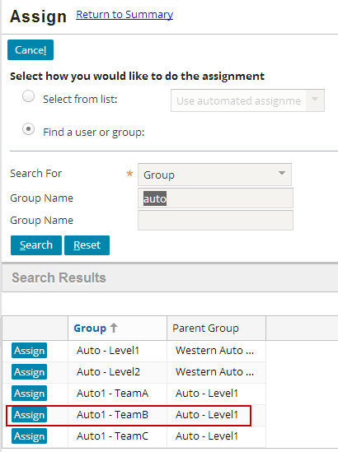

* 1. Did the Global Claim rules execute?
  2. Did the Default Group rules execute?

1. Repeat the process, but explicitly reassign the claim to Chris Craft in the Auto1 - TeamA group. Step through the code.

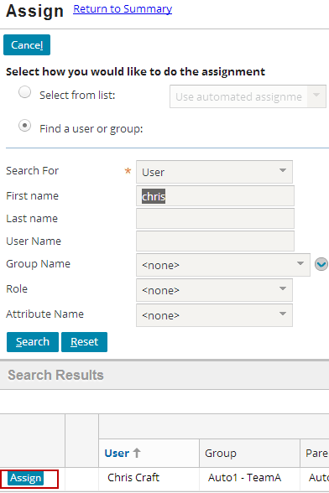

* 1. Did the Global Claim rules execute?
  2. Did the Default Group rules execute?

**Exercise 2: Configuration**

Configure ClaimCenter to meet the following customer requirement from Acme Insurance.

1. This lab depends upon the users and groups created in the "Users and Groups" lab.
2. If you have difficultly, create a new claim to test your changes in Requirements 1 and 2 (instead of reassigning a claim).
3. Theft claims require a police (metro) report. Create these reports with the minimum amount of required fields (Type, City and State).

Requirement 1: Assigning Complex Theft Claims to Complex Thefts - West

Acme Insurance has two groups which handle auto claims in which the entire car was stolen. As a proof of concept, Acme Insurance wants to see all claims where the entire car was stolen assigned to the **Complex Thefts - West** group.

1. Write a claim assignment rule that assigns all claims with a loss cause of "Theft of entire vehicle" to the “Complex Thefts – West” group. (For this requirement, you can ignore the “Complex Thefts – East” group.)

(Normally, this would probably be done in conjunction with segmentation. A segmentation rule would segment the claim based on loss cause, and the assignment rule would react to the claim's segment. To simplify the lab, you can write the assignment rule to react directly to the loss cause.)

**Hint:** To query for the group name, use a method you write in an enhancement.

Test Case 1

When you have completed your configuration, run the following test cases:

1. Restart the server to test your changes. You have to restart the server because you **added** a new rule set. Any subsequent changes you may make to your rule set when testing can be tested after running “Reload Changed Classes” in Studio.
2. Log on to ClaimCenter as Andy Applegate. Navigate to an auto claim whose loss cause is something other than "theft of entire vehicle". Reassign the claim using assignment rules and verify that the claim goes to a group other than Complex Thefts - West.



1. Modify the claim so that the loss cause is "theft of entire vehicle". Reassign the claim using assignment rules and verify that the claim now goes to Complex Thefts - West.

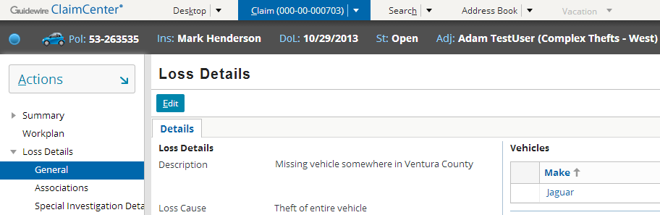

Requirement 2: Assigning Complex Theft Claims Based on Region

The initial proof of concept was successful. Acme Insurance now wants complex theft claims to go to either Complex Thefts - West and Complex Thefts - East, depending on the loss location.

1. Modify the claim assignment rule (or, create a new one and disable the previous one from Requirement 1) so that all claims with a loss cause of "Theft of entire vehicle" are assigned to the Complex Theft group for the region in which the loss occurred. (Do not attempt to assign the claim by location if the loss location is null.)

Test Case 2

When you have completed your configuration, run the following test cases:

1. Log on to ClaimCenter as Andy Applegate. Navigate to an auto claim whose loss cause is "theft of entire vehicle" and who loss location is in a western state, such as California (CA). (If necessary, you can simply modify the loss location of an existing claim.) Reassign the claim using assignment rules and verify that the claim goes to Complex Thefts - West.

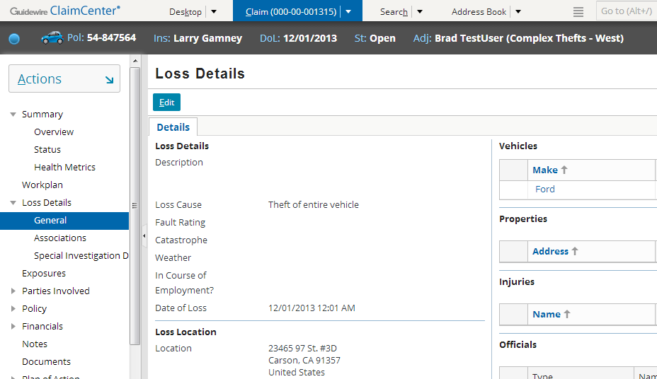

1. Modify the claim so that the loss location is in an eastern state, such as New York. Reassign the claim using assignment rules and verify that the claim now goes to Complex Thefts - East.

